Baker’s Delight Research



Our bakery, Baker’s Delight, offers a wide range of goods and products. We offer breads, cookies, pastries, doughnuts, and many more. We are not as limited as pastry shops.

**Products:**

**Breads:**

Arepa: Arepas are round, flat breads that are baked in butter or oil after making them with masa, water, and salt. Typically, they are split in half horizontally, pan-fried or griddled, and eaten as sandwich bread. (WebsturantStore, 2025)

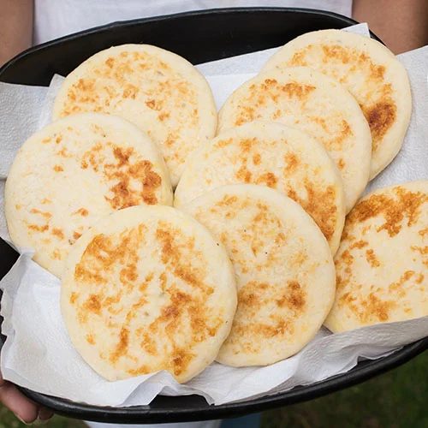

Baguette: Made with wheat, water, yeast, and salt, baguettes are long, cylindrical bread loaves. Baguettes feature a pillowy interior and a thin, crunchy crust because of steam ovens. (WebsturantStore, 2025)

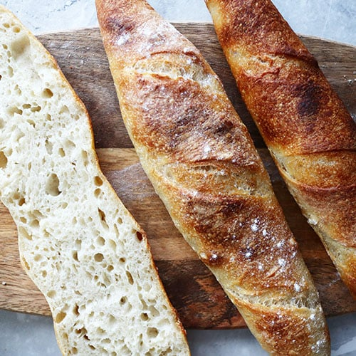

Bagel: A bagel is a kind of bread with a hole in the centre that is shaped like an "O". The ingredients for bagels include barley malt syrup, flour, yeast, water, and salt. Initially boiled, then baked, this bread is thick and fluffy. (WebsturantStore, 2025)

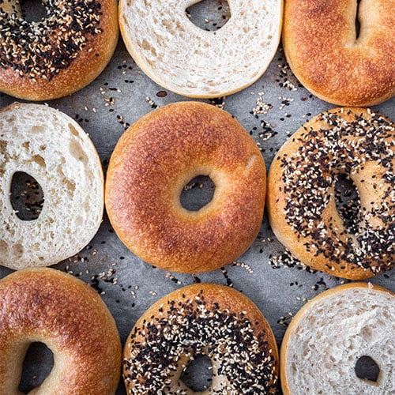

Brioche: The inner layer of brioche, a kind of French bread, is creamy, fluffy, and soft. The ingredients of brioche include flour, milk, eggs, sugar, butter, yeast, salt, and occasionally brandy. (WebsturantStore, 2025)

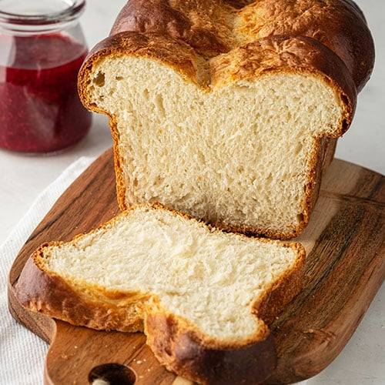

Challah: One kind of bread that is methodically braided into a lovely loaf is called challah bread (pronounced haah-luh). The ingredients of challah, an enriched bread, include flour, water, yeast, salt, sugar or honey, vegetable oil, and eggs. Challah has a soft, flavourful crust that is dark golden brown and has a fluffy interior. (WebsturantStore, 2025)

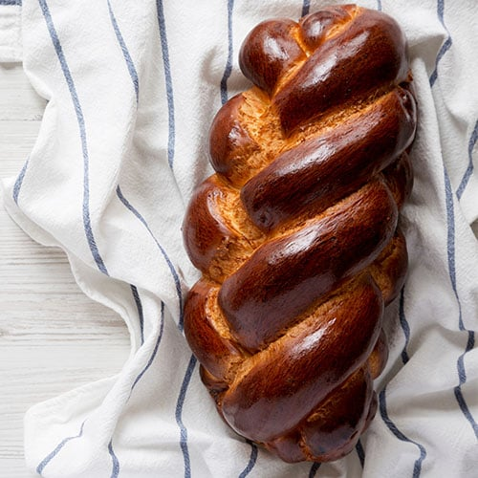

Hokkaido: The Hokkaido region of Japan is where Hokkaido milk bread first appeared. It employs the tangzhong cooking method, which involves pre-heating a portion of the flour in order to gelatinise it and create a paste. Hokkaido bread is renowned for being light and pillowy, and this paste is essential to making it softer and more sensitive. (WebsturantStore, 2025)

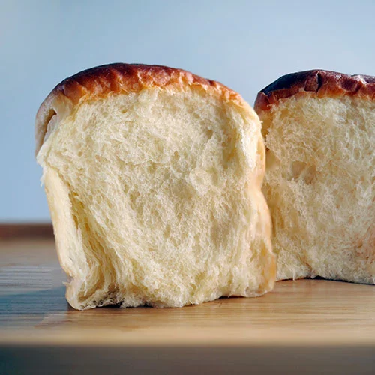

Irish Soda Bread: Baking soda is used as the leavening ingredient in place of yeast to create the rounded, domed loaf known as Irish soda bread. (WebSturantStore, 2025)

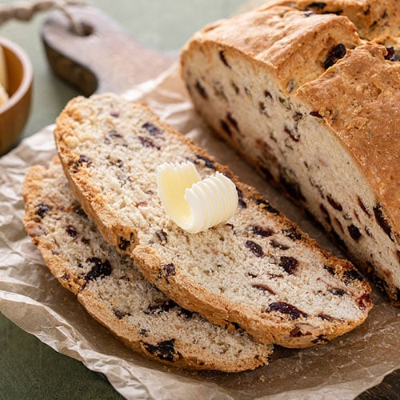

Naan: The ingredients of naan are flour, water, sugar, yeast, yoghurt, vegetable oil, and salt. It has a soft, chewy texture. (WebsturantStore, 2025)

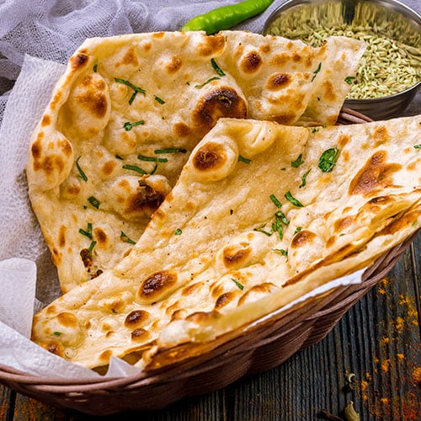

Sourdough: Bread made with a sourdough starter is known as sourdough. A sourdough starter is a flour and water mixture that develops into a leavening agent over time. In addition to giving sourdough its rise, this fermentation process adds the desired "sour" flavour. (WebsturantStore, 2025)

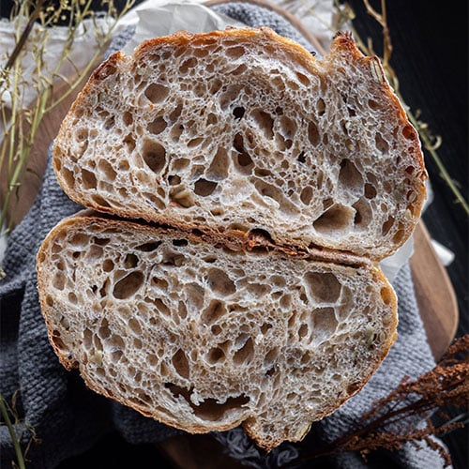

Ry Bread: Loaves of rye bread occasionally include a swirl of both the pale and dark colours of rye flour. Made with rye flour, water, yeast, honey, caraway seeds, and salt, rye bread is denser and more flavourful than other types of bread. (WebsturantStore, 2025)

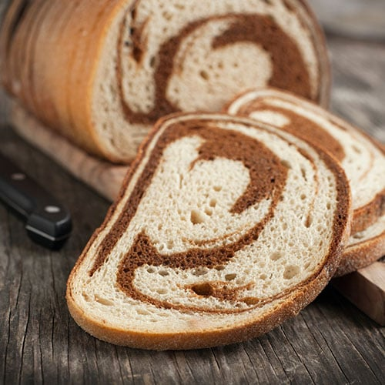

And many more

**Cookies:**

Chocolate chip cookies: Chocolate chip cookies are drop cookies that, depending on the ingredients and cooking time, can be either soft and doughy or crisp and crunchy. (Allrecipes)



Shortbread Cookies: Because of their extremely high butter or shortening to flour ratio, shortbread cookies are called "short." Because they include less flour and sugar than butter cookies, they have a more crumbly and soft feel. (Allrecipes)

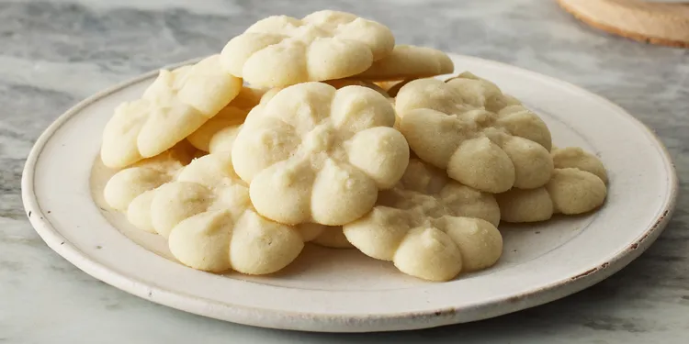

Kiss Cookies: A chocolate kiss is pressed into soft, freshly baked cookies to create kiss cookies. They are quite customisable; you can make the cookie with any base you wish. They are ideal for serving to guests because of their visually appealing look.

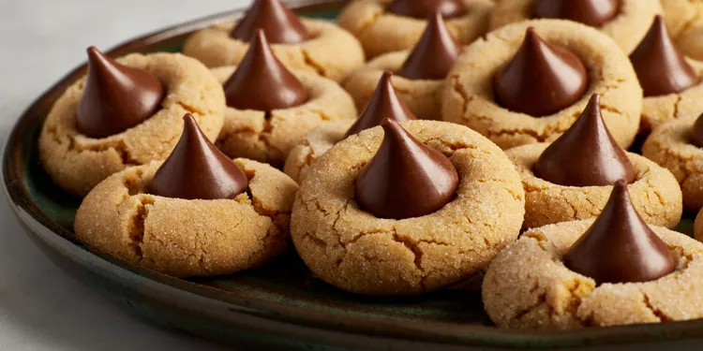

Gingerbread Cookies: Butter, flour, sugar, molasses, cloves, ginger, cinnamon, and nutmeg are basic components. (Allrecipes)

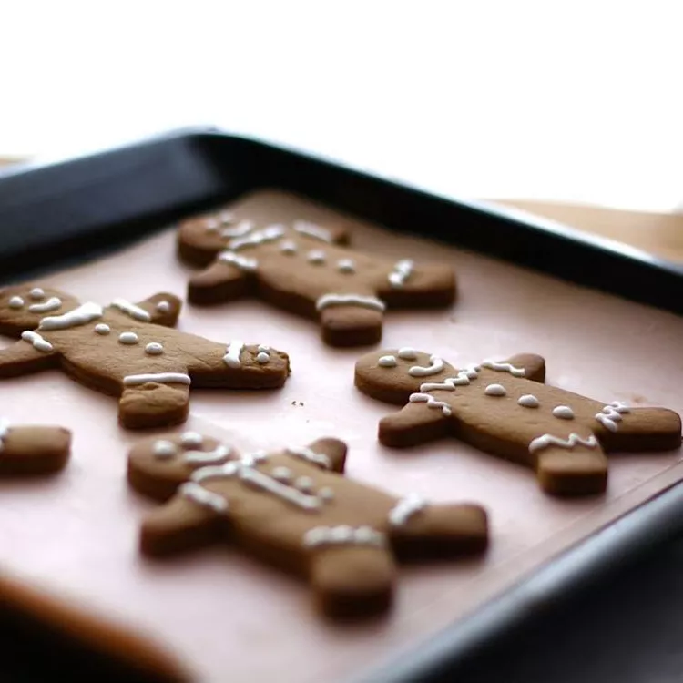

Macarons: Round cookies made of meringue with a creamy ganache filling in between are called macarons. (Allrecipes)

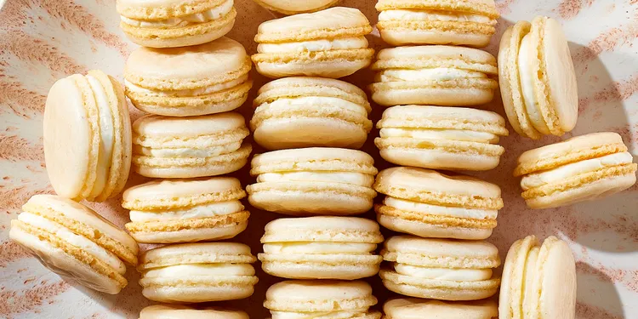

**Pastries:**

Mochi: Japan is the origin of the sweet, chewy rice pastry known as mochi. Mochi are often produced with cooked and pounded rice, however rice flour can also be used to make them. (Delish, 2022)

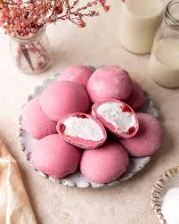

Fruit Tart: The apricot preserve-glazed fruit of your choice goes nicely with the light, slightly tangy, and just-sweet mascarpone filling. Bonus: This recipe is easy and stress-free because the shortbread-like crust is pushed in rather than rolled out. (Delish, 2022)

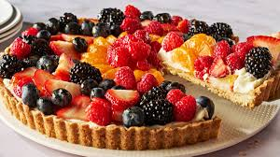

Butter Mochi: The topping alternatives for this recipe are either shredded coconut or a combination of fire and granulated sugar for a crunchy, brûléed, and somewhat bittersweet finish. (Delish, 2022)

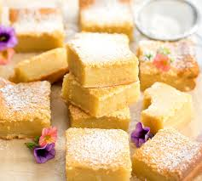

Cheese Puffs: These cheese puffs, also known as gougères, are incredibly tasty, visually stunning, and simple to prepare. (Delish, 2022)

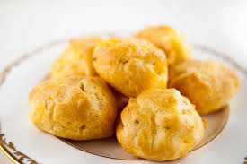

Cinnamon Rolls: The dough is airy and just the right amount of buttery! The filling is where you have some leeway. (Delish, 2022)

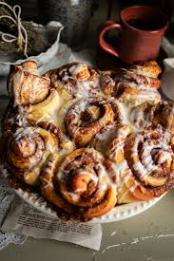

**Doughnuts:**

Cake Doughnuts: These have a thick foundation that can accommodate all of your preferred toppings, including bacon (if you like that) and sprinkles. These doughnuts have a consistency similar to cake, but they are unavoidably drier and have crumbs. Baking powder is used to leaven them, and they are then dipped in oil to cook. (Allrecipes, 2020)

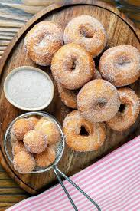

Jelly Doughnuts: Usually circular and holeless in the centre, these traditional doughnuts are leavened with yeast. You get a taste explosion with every mouthful because the centre is packed with jelly, jam, preserves, and even chocolate. (Allrecipes, 2020)



Glazed Doughnuts: With a hole in the centre, this doughnut has the traditional round form. Its foundation is typically yeasted, and its glaze is sweet and sticky. Chocolate glaze is a reasonably typical substitute for the most popular sugar glaze. (Allrecipes, 2020)



Cream -Filled Doughnuts: The yeast base used to make cream-filled doughnuts gives them a light, pliable inside. Though they have a different filling, they are essentially the same as jelly doughnuts. They are filled with custard after the dough has been fried. For a delicious dessert, top with powdered sugar. (Allrecipes, 2020)



Malasadas: Yeast is used to leaven them, which gives them a fluffy, airy texture. Malasadas are coated in sugar after they have been fried. Although they can be purchased loaded with fruit or custard, they are often served plain. (Allrecipes, 2020)



We offer all these and many more, so come on by and take your pick of whatever you are craving. We and all our lovely treats will be right here waiting for you. We are in multiple locations such as Sandton, Braamfontein, Rosebank, Krugersdorp, Rodepoort and Randfontein.

We also have upcoming events at all our branches on various dates, 29 August 2025, 1st September 2025, 24 September 2025, 3 October 2025, 31 October 2025, 5 November 2025, 25 November 2025, 1st December 2025, 16 December 2025, 24, 25, 26, 30,31 December 2025, 1st January 2026. On these dates we will be having “Family days” prices will be dropped, games will be played and treats will be baked and served and various artists will be there to perform, so stop by on these dates and lets have fun!

**Visual representation**

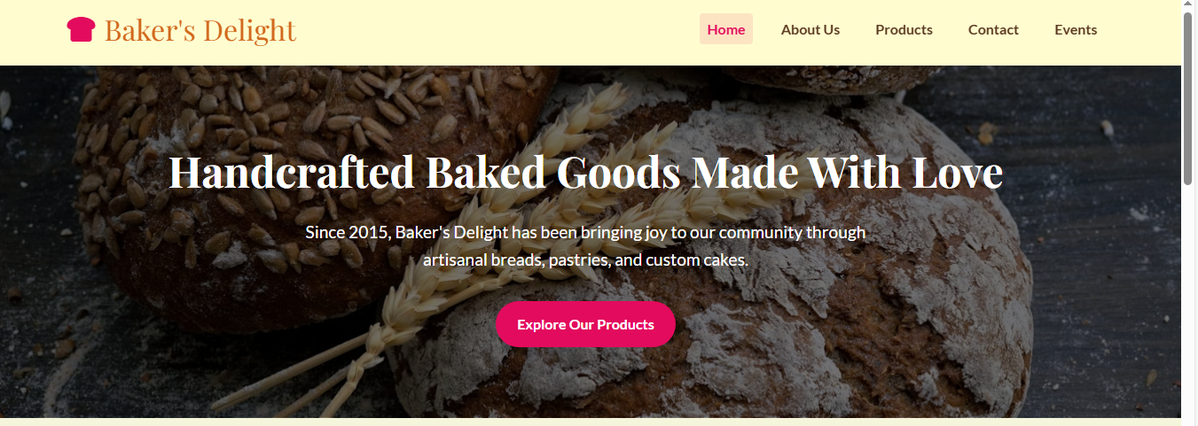

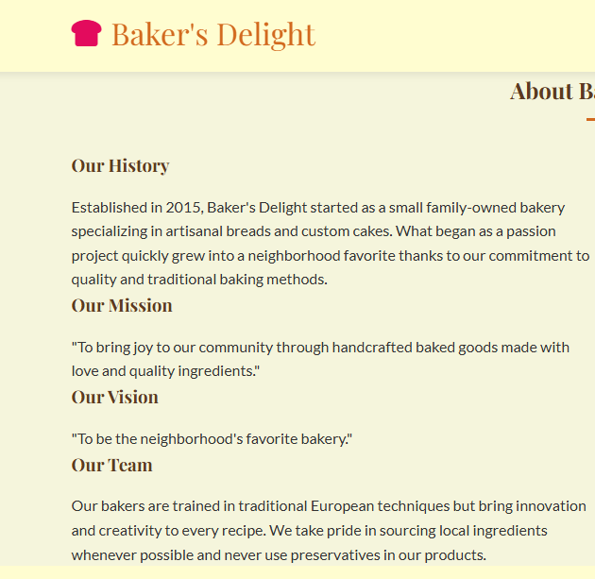

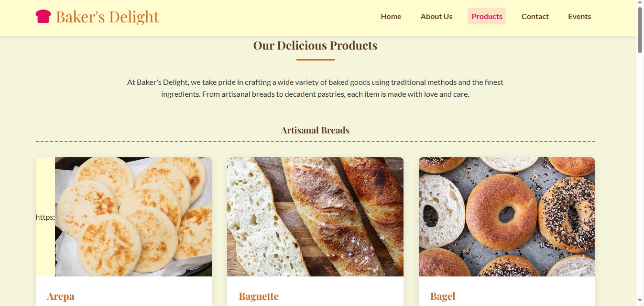

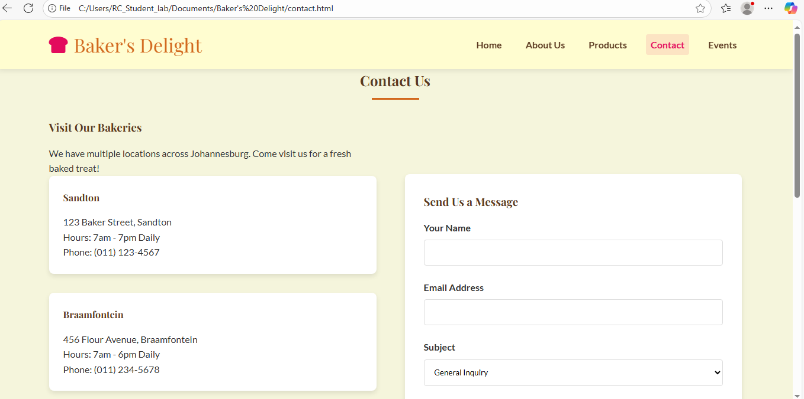



# References

Fincher, M. Allrecipes. 20 different types of doughnuts you need to know, 28 July 2020. [online] Available at:

< <https://www.allrecipes.com/gallery/types-of-donuts/> >

[Accessed 21 August 2025]

Fincher, M. Allrecipes, 2025. 30 most popular types of cookies. [online] Available at:

< <https://www.allrecipes.com/gallery/most-popular-types-of-cookies/> >

[Accessed 21 August 2025]

Lowder, C. Delish. 38 pastry recipes from around the world, 22 September 2022. [online] Available at:

< <https://www.delish.com/cooking/recipe-ideas/g41299455/pastry-recipes/> >

[Accessed 21 August 2025]

WebsturantStore. Types of bread, 11 June 2025. [online] Available at:

< <https://www.webstaurantstore.com/article/801/bread-types.html?srsltid=AfmBOoqJo0aGrgTg2r3Ch6_8e_fEfst_LbewiytkSgYnwuF0cECzqww_>>

[Accessed 20 August 2025]